Scams Messaging
As states work through their Medicaid redetermination processes, scams have become a growing concern for state and federal agencies. There have been reports of scams targeting potential/current Medicaid enrollees by asking for financial compensation over the phone to retain Medicaid coverage and/or offering enrollment in fake or misleading plans. GMMB has developed English-and Spanish-language social posts below to ensure families going through the redeterminations and enrollment process know how to protect themselves from scams and bad actors.

We have indicated in all CAPS where you can add the name of your state Medicaid/CHIP program and enrollment link (you can find information on your state’s programs at https://www.insurekidsnow.gov/coverage/index.html).
These social posts can be used with the corresponding graphics across Twitter, Facebook, and Instagram. For the best quality, please download the high-resolution graphics from the folder here instead of saving the images directly from this document. To maximize space for content, we recommend using bit.ly to shorten any links you plan to include. Please note that you cannot add links to your Instagram posts. Instead, links can be added to your Instagram bio.

Post Series: Medicaid Scams
Language | Graphic (download here) | Post Copy
English | 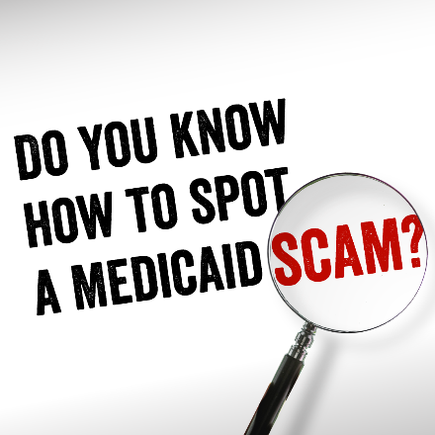 | Idaho Medicaid renewals are happening now! It’s important to respond quickly to requests for information, but always make sure requests are coming from a credible source. Look for official government seals & logos. Learn more here: https://idalink.idaho.gov/  Avoid Medicaid scams by finding official enrollment assistance to help you manage your coverage. Find yours here: https://idalink.idaho.gov/  Make sure your address is up to date with Idaho Medicaid to ensure you are receiving accurate messages. Update your address here: https://idalink.idaho.gov/  Idaho Medicaid enrollees: Avoid scams. If anyone claiming to be Idaho Medicaid or the Idaho Department of Health and Welfare and asks you for money be careful.  Scams have been reported impersonating Idaho Medicaid. For accurate renewal information, visit https://idalink.idaho.gov/
Spanish | 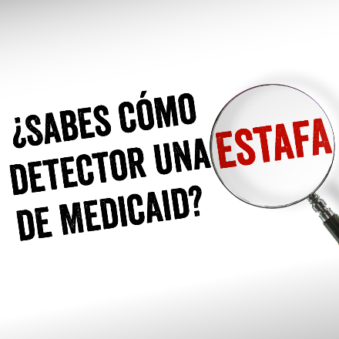 | ¡Las renovaciones de Idaho Medicaid están ocurriendo ya! Es importante responder rápidamente a solicitudes de información, pero asegúrese de que vengan de una fuente confiable. Busque los sellos y logotipos oficiales del gobierno. Aprenda más: https://idalink.idaho.gov/  Evite las estafas de Medicaid al obtener asistencia de inscripción oficial para ayudarlo a tramitar su cobertura. Encuentre asistencia aquí: https://idalink.idaho.gov/  Asegúrese de que Medicaid tenga su dirección actualizada para que pueda recibir mensajes precisos y confiables. Actualice su dirección aquí: https://idalink.idaho.gov/  Personas inscritas en Idaho Medicaid. Evite las estafas de Idaho Medicaid Si alguien que dice ser https://idalink.idaho.gov/ le pide dinero, tenga cuidado.  Se han reportado estafas haciéndose pasar por Idaho Medicaid Para obtener información confiable sobre la renovación, visite https://idalink.idaho.gov/

