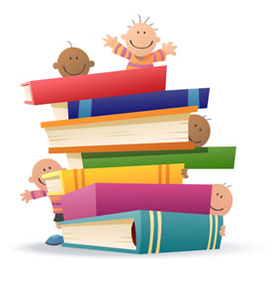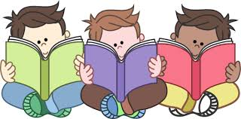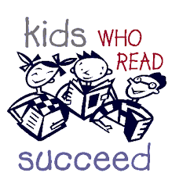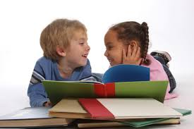

### **Why read with your child?**

* It develops strong family relationships
* It helps prepare children for school, and develops healthy learning habits
* It helps children with basic grammar, reading, and communication skills
* It helps children with concentration and discipline
* It gives children a framework to develop a love for reading throughout their lives

## **Make Reading**

## **Fun!**

## **and**

## **Check Out Your Local Library!**

All of this information can be found on the AAP Literacy Tool Kit Website

Your Doctors Office Here

[Street Address] [City], [State] [Postal Code]  
[Web Address]

Read.

Read. Read.

***1 to 2 years old!***

* Identify objects on each page; this is how your toddler learns!
* Make reading part of your nightly bedtime routine!
* Let your toddler hold the book and turn the pages
* Repetition is key, pick out favorite books to read over and over
* Be Silly! Use different voices and animal noises
* Studies show that children under 2 DO NOT learn from screen time!

***3 to 4 years old!***

* Keep your child engaged by asking questions
* Allow your child to tell you stories
* Read alphabet, counting, and color books
* Children love books about family and friends!
* Have your children read things with you when you’re out and about, such as menus and billboards

**Reading with your….**

# Recommendations

***Baby!***

* Hold your baby on your lap!
* Get books that include pictures of babies
* Find books that include rhymes and songs
* Always point at the pictures, this is how your baby learns!
* Studies show that children under 2 DO NOT learn from screen time!